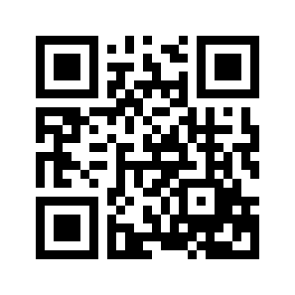
Contact Information Sheet
Physical Address: Sacramento Office (SMF)
2975 Oates Street, Suite #20
West Sacramento, CA. 95691
Communications: Main Office: (916) 375-7125
Toll Free: (877) 653-6420
Fax: (916) 375-7132

General Email: info@shipmld.com

Individual Email: Corynn Acker corynn@shipmld.com
Kirk Bettencourt kirk@shipmld.com
Jill Bettencourt jill@shipmld.com
Carrie Finnigan carrie@shipmld.com
Kali Garcia kali@shipmld.com
Karinah Hazewood karinah@shipmld.com
Scott Hulsey scott@shipmld.com
Amanda Lawand amanda@shipmld.com
Joaquin Murrieta joaquin@shipmld.com
Katelyn Ray katelyn@shipmld.com
Emil Sabate emil@shipmld.com
Jody Snider jsnider@agility.com
Kori Thornton kori@shipmld.com
Julie Trotta julie@shipmld.com

Operating Hours: Monday-Friday 7:00 AM to 7:00 PM
Saturday-Sunday (hours by special arrangement)
NOTE: We are “on call” for our customers 24-7-365.

Facility Profile: MyLogisticsDept is located 15 miles south of Sacramento
International Airport (just off I-80). This facility includes
2,200 sq. foot of office space and provides 50,000 sq. foot of
secure warehouse space.

Effective Date 9/21/2018

